CONTEXT DIAGRAM
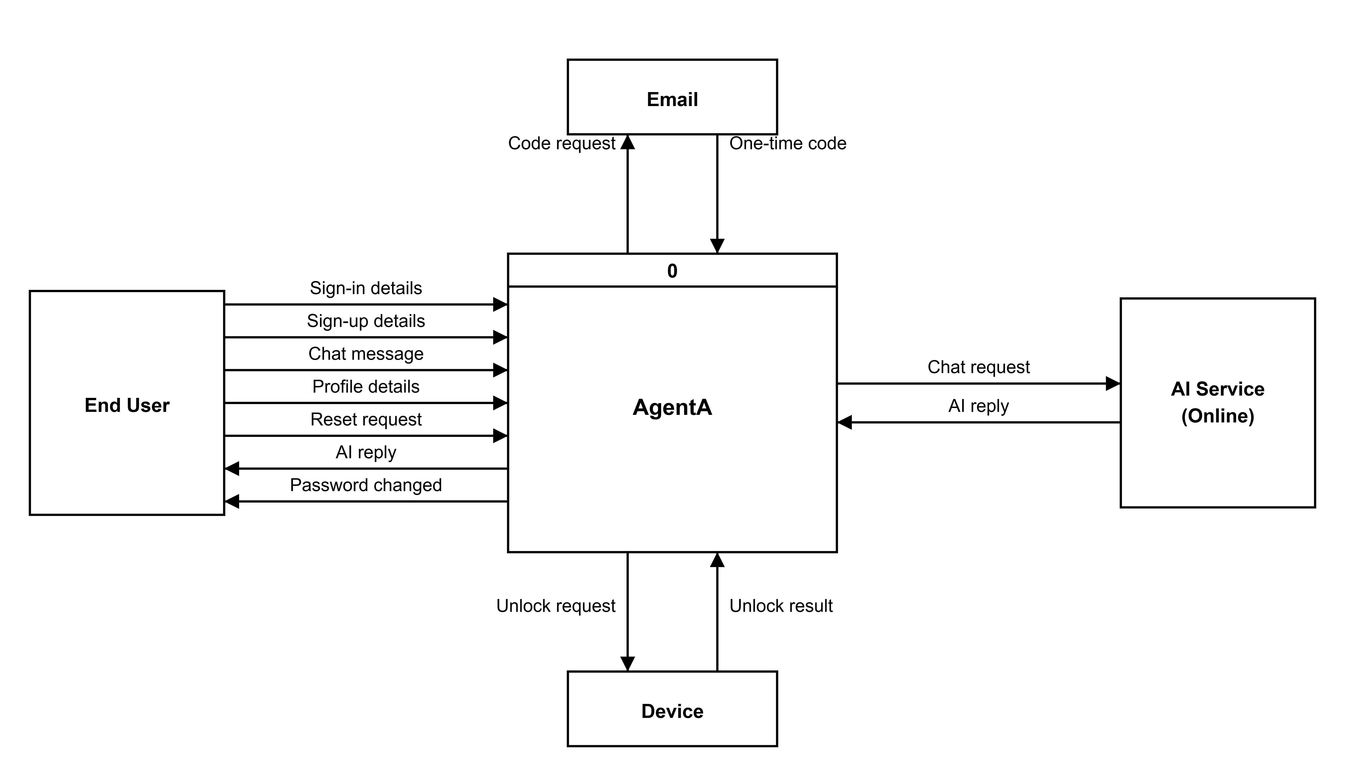
Figure 1. Context Diagram of the AgentA System
Narrative Flow of Data
The diagram shows AgentA as one process, numbered 0, and that single process is the whole system. Four outside parties work with it. The End User signs in or signs up by sending sign-in details and sign-up details to process 0, and sends chat messages, profile details and a reset request while using the app. Process 0 answers the End User with AI replies and a confirmation that the password changed. When the device is online, process 0 sends a chat request to the AI Service (Online) and receives the AI reply back. When a password is forgotten, process 0 sends a code request to Email, and Email returns a one-time code. Process 0 also sends an unlock request to the Device, and the Device sends back the unlock result so the End User can get in.

LEVEL 0 DFD (DIAGRAM 0)
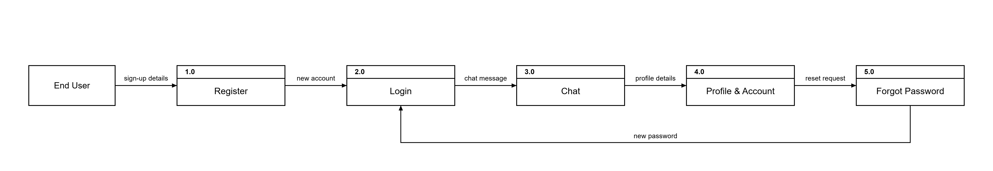
Figure 2. Level 0 DFD (Diagram 0) of the AgentA System
Narrative Flow of Data
The End User is the only person using the app. 1.0 Register is where the user signs up and a new account is created. 2.0 Login signs the user in. 3.0 Chat is where the user sends and reads messages. 4.0 Profile & Account lets the user view and change the profile and account. 5.0 Forgot Password recovers the account if the user forgets their password, and once the password is reset the user returns to 2.0 Login to sign in with the new password. These five processes are the user's main functions, drawn here in the order the user meets them. The data stores behind each function and the detail inside every process appear in the Level 2 figures that follow.

LEVEL 2 DFD PROCESS 1.0 (REGISTRATION)
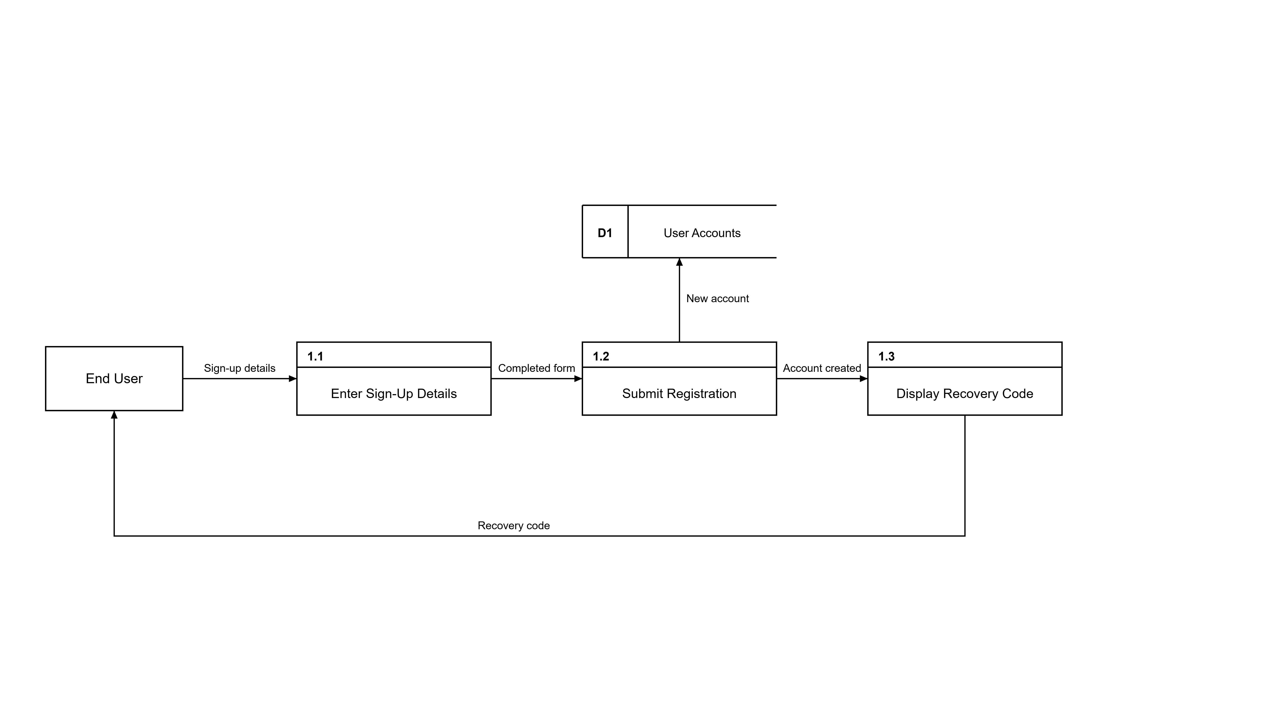
Figure 3. Level 2 DFD Process 1.0 (Registration)
Narrative Flow of Data
Registration starts when the End User opens the sign-up page; process 1.1 Enter Sign-Up Details takes the sign-up details that the user types, such as an email address and a password. The completed form flows into 1.2 Submit Registration, which creates the account and sends the new account into D1 User Accounts. Once the account exists, the account created message moves to 1.3 Display Recovery Code, which shows the one-time recovery code on the screen. The recovery code flows back to the End User, who is asked to keep it safe for recovering the account later. With the account safely stored in D1 User Accounts and the recovery code in the user's hands, the registration is complete.

LEVEL 2 DFD PROCESS 2.0 (LOGIN)
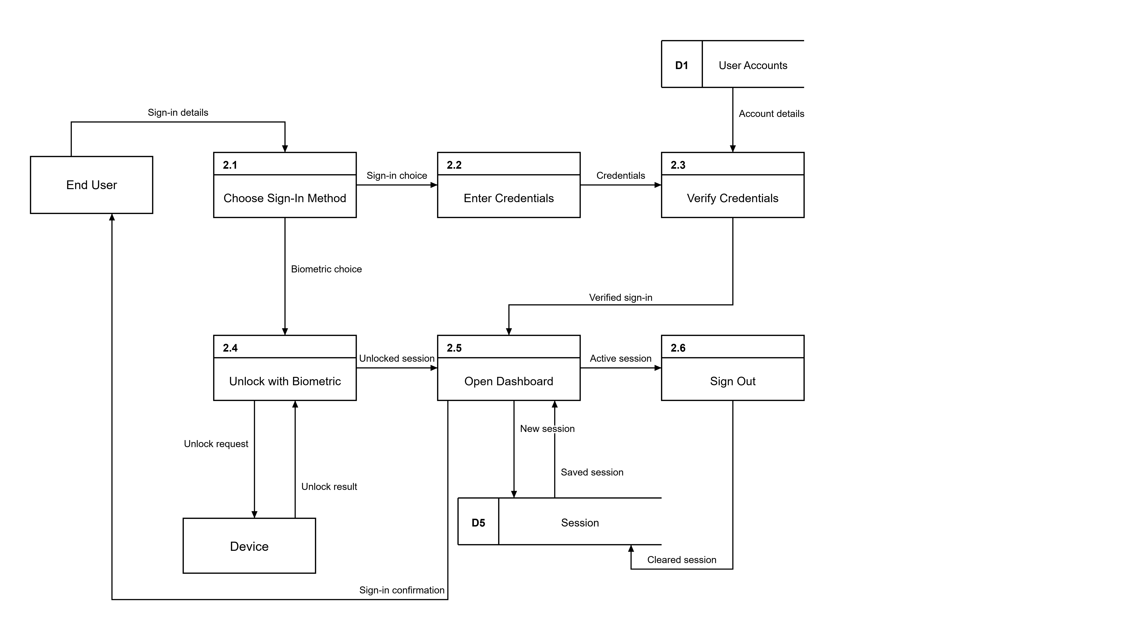
Figure 4. Level 2 DFD Process 2.0 (Login)
Narrative Flow of Data
When the End User opens the app, process 2.1 Choose Sign-In Method starts the login by offering either a password sign-in or a biometric unlock. Choosing the password route moves to 2.2 Enter Credentials, where the user types the sign-in details, and the typed credentials flow into 2.3 Verify Credentials. Verification checks the account details kept in D1 User Accounts, and once the details match, a verified sign-in moves on to 2.5 Open Dashboard. Choosing the biometric route goes to 2.4 Unlock with Biometric, which sends an unlock request to the Device and continues only after the Device returns a successful unlock result. When the dashboard opens, 2.5 Open Dashboard shows the sign-in confirmation back to the End User and writes a new session into D5 Session, while an earlier saved session can also be read from D5 Session when the app starts again. Finally, 2.6 Sign Out ends the active session and clears the saved session from D5 Session.

LEVEL 2 DFD PROCESS 3.0 (CHAT)
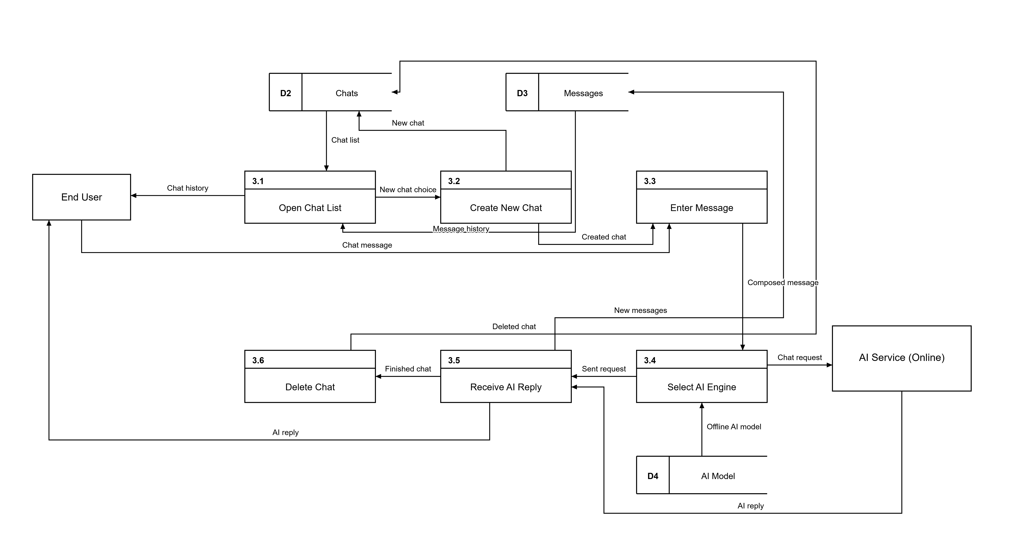
Figure 5. Level 2 DFD Process 3.0 (Chat)
Narrative Flow of Data
When the End User opens the chat area, process 3.1 Open Chat List reads the chat list from D2 Chats and the message history from D3 Messages, and shows the chat history back to the End User. Creating a new chat through 3.2 Create New Chat saves a new chat in D2 Chats, and the created chat moves on to 3.3 Enter Message. There the End User types a chat message, and the composed message flows into 3.4 Select AI Engine. Process 3.4 chooses the AI engine, using the offline AI model stored in D4 AI Model when the device is offline, and sends the chat request to the AI Service (Online) when the device is online. The AI Service returns the AI reply to 3.5 Receive AI Reply, which shows the AI reply to the End User and saves the conversation as new messages in D3 Messages. Finally, 3.6 Delete Chat removes a chat from D2 Chats when the user deletes it.

LEVEL 2 DFD PROCESS 4.0 (PROFILE & ACCOUNT)
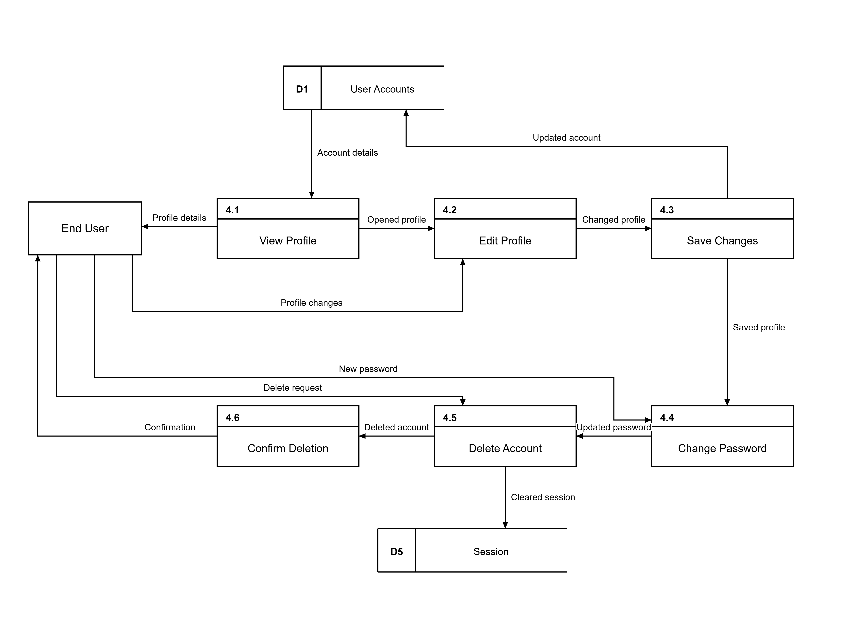
Figure 6. Level 2 DFD Process 4.0 (Profile & Account)
Narrative Flow of Data
Profile management starts when process 4.1 View Profile reads the account details kept in D1 User Accounts and shows the profile details to the End User. The opened profile moves to 4.2 Edit Profile, where the End User changes the profile details and sends the profile changes. The changed profile flows into 4.3 Save Changes, which writes the updated account back into D1 User Accounts. The saved profile continues to 4.4 Change Password, where the End User enters a new password to update. The updated password moves to 4.5 Delete Account, where the End User can send a delete request; when the account is deleted, the cleared session is removed from D5 Session. Finally, the deleted account message goes to 4.6 Confirm Deletion, which shows the confirmation to the End User.

LEVEL 2 DFD PROCESS 5.0 (FORGOT PASSWORD)
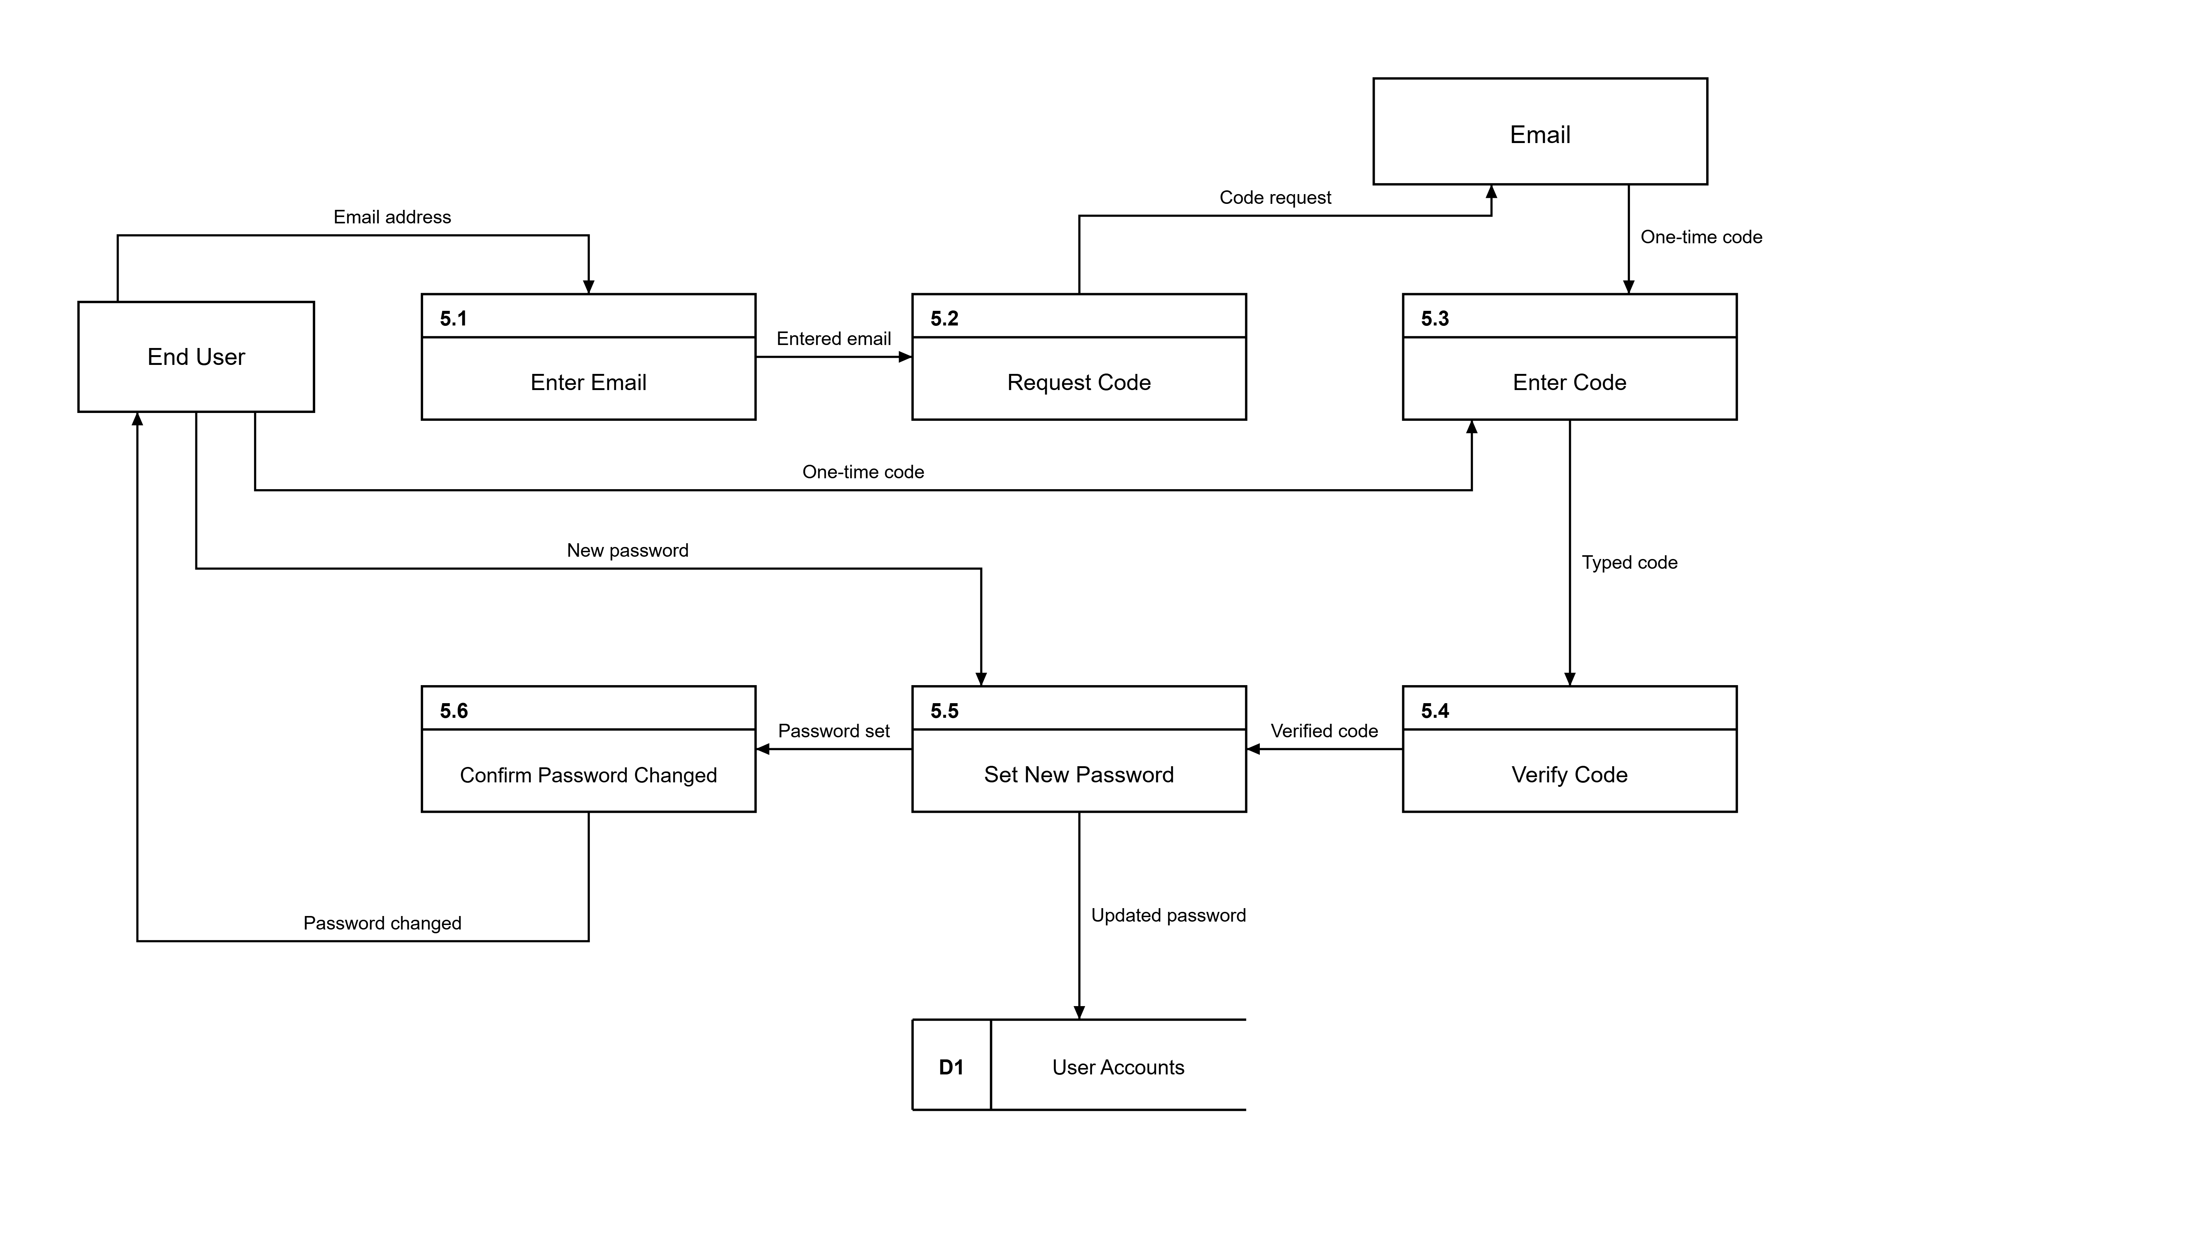
Figure 7. Level 2 DFD Process 5.0 (Forgot Password)
Narrative Flow of Data
When the End User forgets a password, process 5.1 Enter Email takes the email address typed on the reset screen. The entered email flows into 5.2 Request Code, which sends a code request to Email and asks for a one-time code to be delivered. The Email entity sends the one-time code to 5.3 Enter Code, and the End User types that same one-time code to continue. The typed code flows into 5.4 Verify Code, which checks the code and passes a verified code on to 5.5 Set New Password. The End User types a new password into 5.5, which sends the updated password into D1 User Accounts. Finally, the password set result moves to 5.6 Confirm Password Changed, which shows the password changed confirmation back to the End User.

